lModule and Position
Home New Style 1
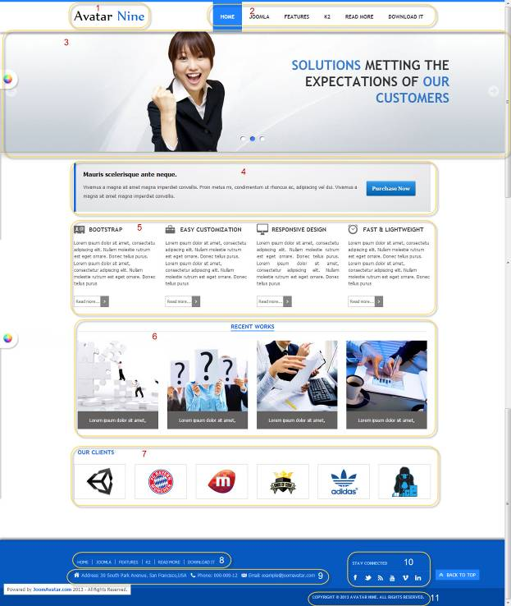

All of our templates are packed with:
- Extensions - These are modules/plugins/component to use on this template.
- Template - This is the template only install file
- Quickstart - This is your main quickstart package, it will help you to reprodude demo.
- Documentation
If this template is not downloaded directly from amazing-templates.com. Please, go to our website and download full template pakage.
This documentation file helps you build your site manualy

Menu item type: Single Article
Article Name: Home Blank

1.
Module Type: Custom HTML
Module Name: Logo (hide title)
Module Class Suffix: no-padding-marging avatar-template-logo
Position: Top-left

HTML source code:
<p><a href="Your Link Site "><span style="color: #000;">Your</span> Site Name</a></p>

2.
Module Type: Menu
Module Name: Main Menu
Module class suffix: _menu no-padding-marging
Menu class suffix: avatar-main-menu
Alternative layout: Responsive
Position: Top-right

3.
Module Type: Avatar Articles Nivo
Module Name: Banner Tool Home
Module Class Suffix: avatar-caption no-padding-marging avatar-banner-full
Module Postion: Tool (width of TOOL BLOCK is 100% (configuration in templates manager))

DATA
Go to Content Manager.
Creat New Category.
Create articles in category just created.
In a newly created articles, Select intro image and written content slide.
Then go to the Banner Tool Home Manager.
Select the category for slidershow.

4.
Module Type: Custom HTML
Module Name: Slogan-home-new-style-1
Module class suffix: avatar-slogan no-padding-margin-side
Position: Content-top

HTML source code:
<p style="float: right; margin: 30px 20px;"><a class="btn" href="#" target="_blank"><strong style="font-size: 13px; line-height: 24px;">Purchase Now</strong></a></p>
<p><strong style="line-height: 24px; font-size: 16px; color: black;">Many showcase of Articles-News Flash Module. </strong></p>
<p><span style="line-height: 24px; font-size: 13px;">Features, Recent Works, Our Client Block, they are another Alternative layouts of Articles - News Flash Module</span></p>
<p><span style="line-height: 24px; font-size: 13px;">Many way to show your articles list with awesome effects</span></p>

5.
Module Type: Avatar Template Showcase
Module Name: Features Home News Style
Module class suffix: no-padding-marging
Module showcase: features
Position: content-top
Column: 4

DATA
Go to Content Manager.
Creat FEATURES_1 Category.
Create articles in category just created.
In a newly created articles, and written content slide.
Then go to the Features Home News Style Manager.
Select the category for display.

6.
Module Type: Avatar Template Showcase
Module Name: RECENT WORKS (show title)
Module class suffix: avatar-module-7 avatar-heading-center no-padding-marging
Module showcase: portfolio
Position: content-top
Column: 4

DATA
Go to Content Manager.
Creat WORKS Category.
Create articles in category just created.
In a newly created articles, and written content slide.
Then go to the RECENT WORKS Manager.
Select the category for display.

7.
Module Type: Avatar Template Showcase
Module Name: OUR CLIENTS (show title)
Module class suffix: no-padding-marging
Module showcase: clients
Position: content-top
column : 6

DATA
Go to Content Manager.
Creat CLIENTS Category.
Create articles in category just created.
In a newly created articles, and written content slide.
Then go to the OUR CLIENTS Manager.
Select the category for display.

8.
Module Type: Menu
Module Name: Footer Menu
Module class suffix: no-padding-margin-side
Menu class suffix: avatar-footer-nav
Alternative layout: Responsive
Position: Footer-Left

9.
Module Type: Custom HTML
Module Name: Address
Module Class Suffix: avatar-module-border-top avatar-footer-address no-padding-marging
Position: Footer -left

HTML source code:
<ul style="display: table;">
<li class="avatar-address"><span style="line-height: 1.3em;">Address: Your Address</span></li>
<li class="avatar-phone"><span style="line-height: 1.3em;">Phone: Your Phone Number</span></li>
<li class="avatar-email"><span style="line-height: 1.3em;">Email: Your email</span></li>
</ul>

10.
Module Type: Custom HTML
Module Name: STAY CONNECTED
Module Class Suffix: no-padding-margin-side social-heading
Position: Footer -right
HTML source code:
<div class="avatar-footer-social avatar-module-border-top">
<a class="facebook" href="Your Facebook Link"> </a>
<a class="twitter" href="Your Twitter Link"> </a>
<a class="feed" href="Your Feed Link"> </a>
<a class="youtube" href="Your Youtube Link"> </a>
<a class="vimeo" href="Your Vimeo Link"> </a>
<a class="linkedin" href="Your Linkedin Link"> </a>
</div>

11.
Module Type: Custom HTML
Module Name: copyright
Module Class Suffix: avatar-copyright
Position: Footer

HTML source code:
<p><a href="www.joomavatar.com">Copyright © 2013 Avatar Nine. All Rights Reserved.</a></p>

